1. Write an HTML code to create a frameset having header, navigation and content sections

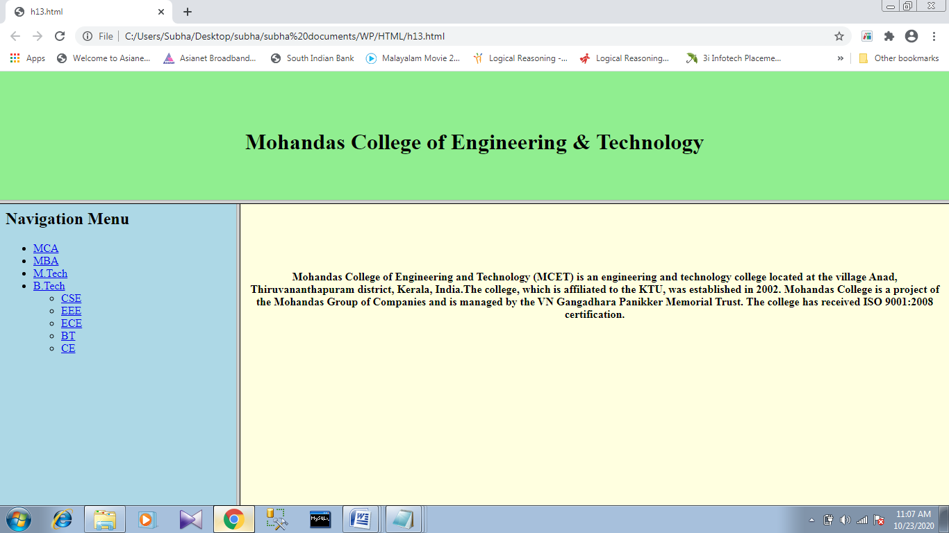

1. Design the following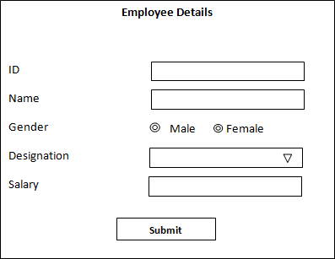
2. Create a web page that uses external style sheet for formatting the body tag attributes, heading tags and lists.

Display body elements with blue background, white font color.

Display all listing elements in green color and set font size to x-large.

Display the heading element in red color and use decoration tags